**­­­**

Class 7

**Lecture 5**

**Basic Algorithm**

**Algorithm and Flowchart.**

**Programming**

**&**

**Algorithm**



**Lab Objectives:**

* What is Algorithm?
* Algorithm Details.
* Some Algorithm Example?
* What is Loop? How it works?

**What is Algorithm?**

An algorithm is a step by step method of solving a problem. It is commonly used for data processing, calculation and other related computer and mathematical operations.

In a non-technical approach, we use algorithms in everyday tasks, such as a recipe to bake a cake or a do-it-yourself handbook.

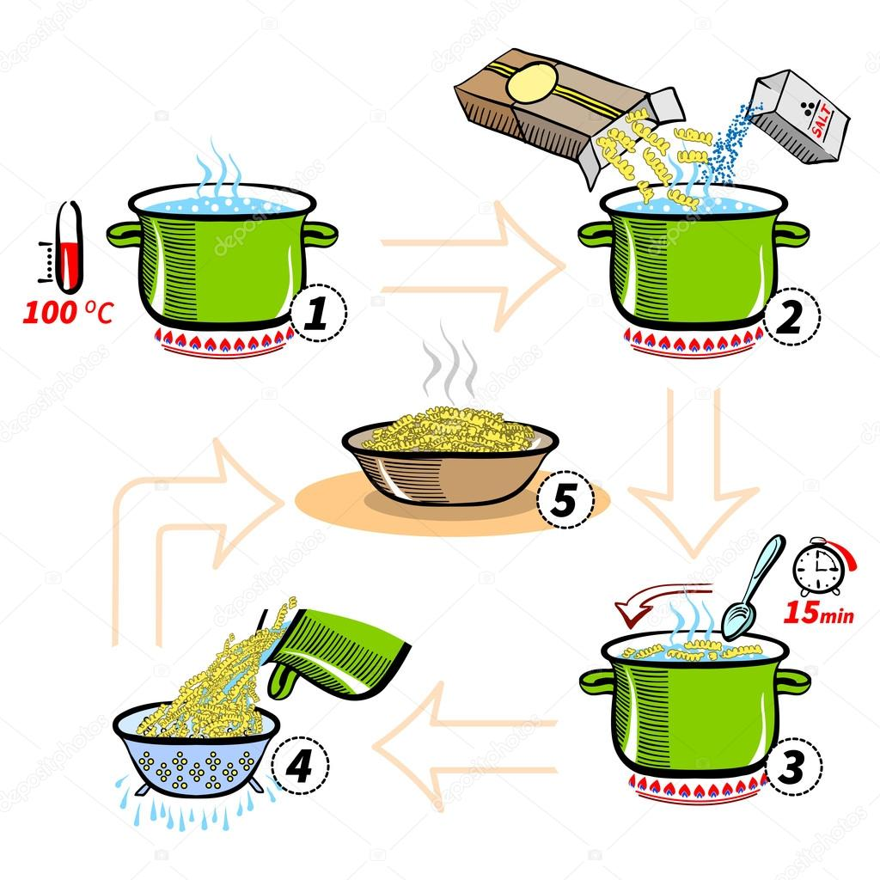

Consider you are at sleep and suddenly your alarm clock starts ringing. Don’t you take decisions then? Yes, you do. See this image and you will find something interesting.

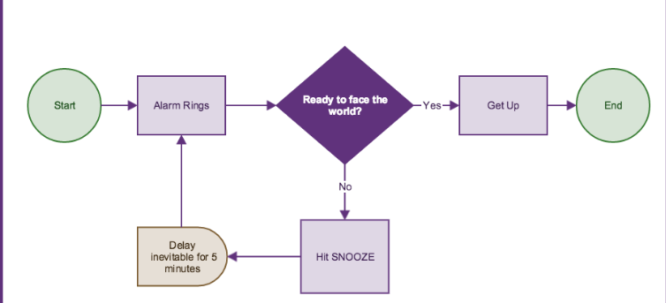

Again, Suppose You live in Dhaka and want to go to Coxbazar. So If want to write your plan step by step that will be considered as an algorithm. So to reach your destination lets make an Algorithm.

1. **Start**
2. **Get ready take necessary things and leave home**
3. **Find a car/ rickshaw to reach to nearest train station**
4. **Buy a ticket of Dhaka-Chittagong and ride on train.**
5. **Once You reach Chittagong leave train station and buy a Bus ticket of Coxbazar.**
6. **After purchasing ticket, get on Bus.**
7. **Stop**

Once you find yourself in Coxbazar. All step is done. Marks as **Stop**.

We can also represent this algorithm by using dataflow diagram. Using diagram gives us better understanding within a short time about a algorithm.

The above algorithm is from our real life. What if we want to instruct our computer we will have to instruct as per a specific algorithm. We will define algorithm by our self. So let’s check some common, easy and important algorithm for more understanding.

Before moving towards next have a look on different shapes and their meaning of Flowchart.

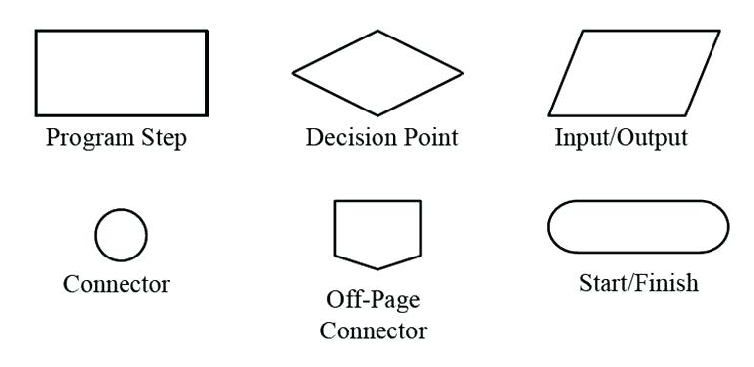

**Example 1**: An Algorithm of adding two number in Calculator.

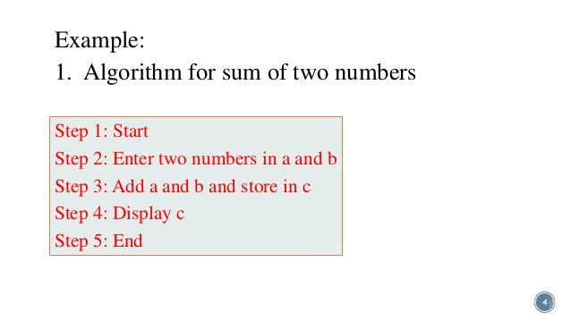

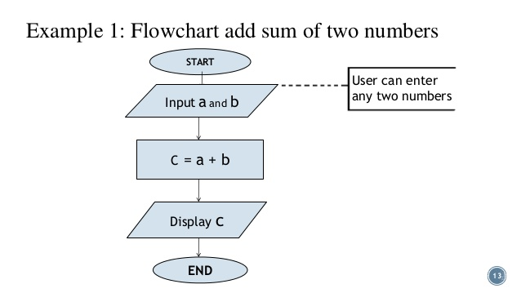

By using flowchart

**Example 2**: An Algorithm of determining greater number between two number. (using flowchart).

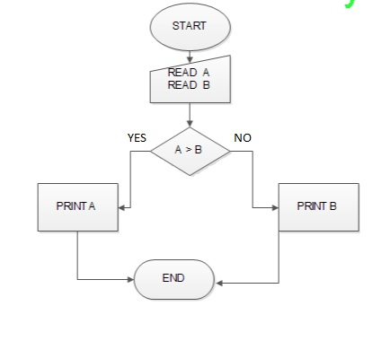

**Example 3**: An Algorithm of determining even and odd between two number. (using flowchart)

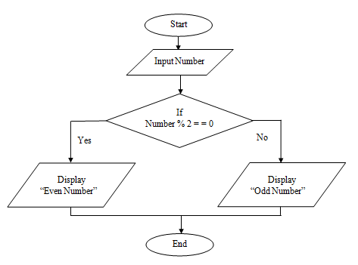

**Example 4**: An Algorithm of finding leap year. (using flowchart).

